|  |
| --- |
| SOFTWARE REQUIREMENTS SPECIFICATION SAMPLE DOCUMENT |
| OrangeHRM – My Info Module Qualifications – new feature |
| Project Functional Requirement Specification , Version 3.3 |
|  |
|  |
|  |

**This is a sample SRS document for the live project training on http://softwaretestinghelp.com. Please read this document and use it as a reference for our live software testing project.**

**22nd of April 2022**

## **My info Module**

My Info Module is a powerful tool providing employees of the company with the ability to view relevant information such as personal information and updating personal information with an internet enabled PC without having to involve the HR department.

The functionality of this module spans through the entire system, making information available anywhere, anytime. All information is subject to the company's defined security policy, where he/she can only view the information he/she is authorized to. An ESS-User can only edit certain fields in the ESS Module, maintaining the security and confidentiality of employee information.

New area will be added called Qualifications.

### Qualifications

To add a qualifications, click on “Qualifications” in My Info section under “Report-to” option and the screen as shown in Figure 1.1 will appear.

**Figure 1.1**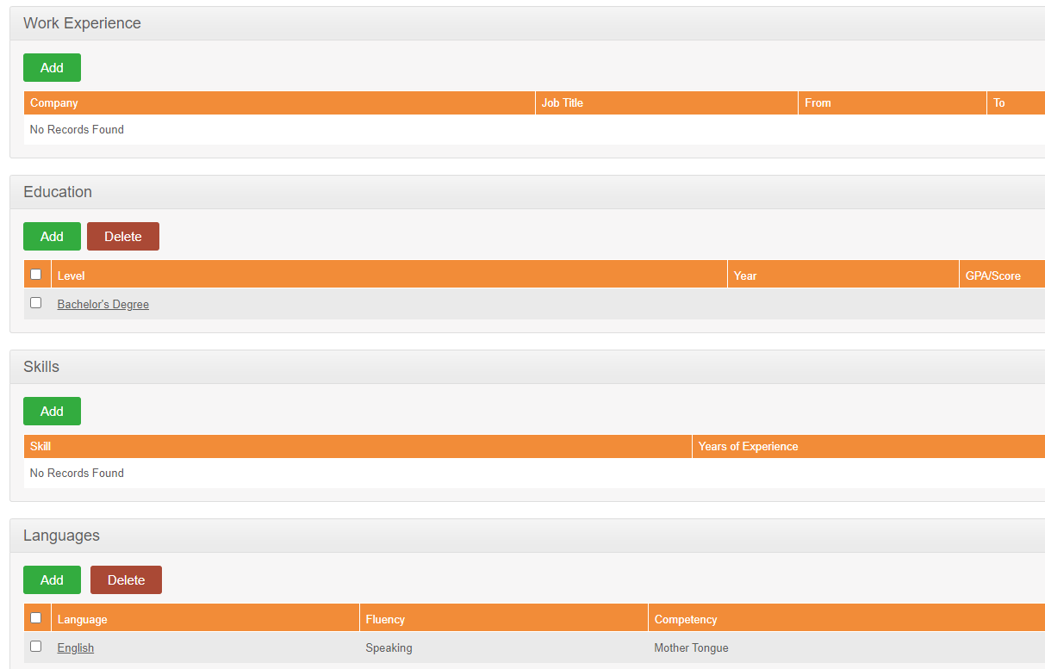

Add button will be visible all the time, delete button will appear if at least one record is registered.

The following options are available under the Qualifications section:

**● Work Experience**

Your previous work experiences can be entered here. To enter previous work experiences, click “Add” under “Work Experience” and the screen as shown in Figure 1.2 will appear.

**Figure 1.2** 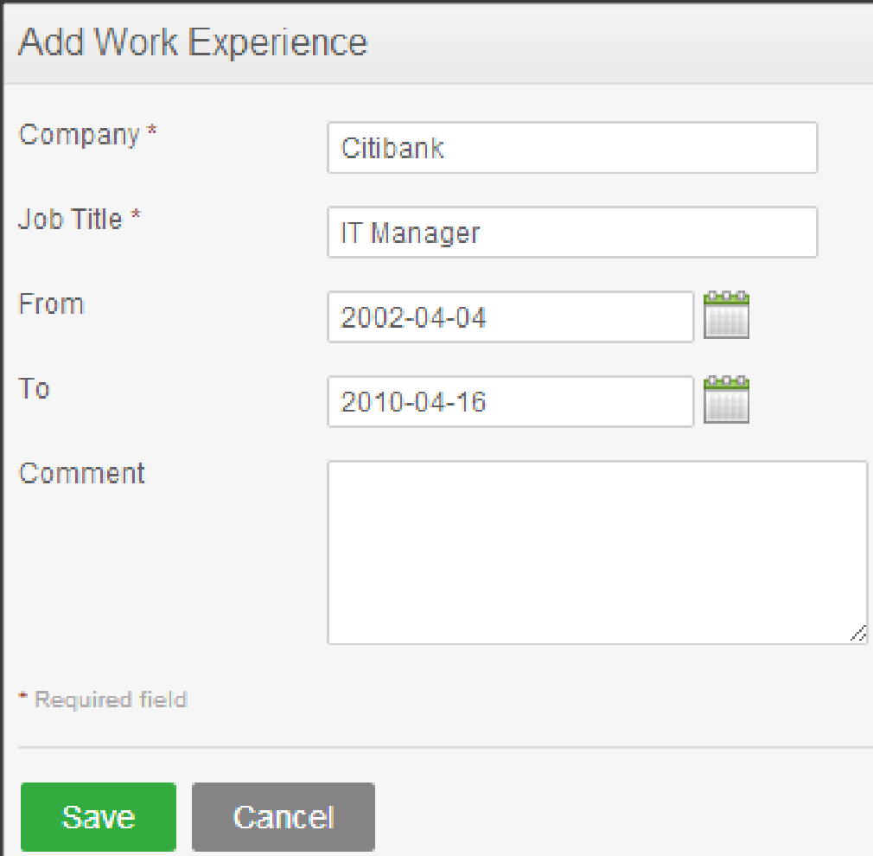

The form will contain

* Company – mandatory field – string type – max 100 characters. When max is reached user cannot type
* Job Title – mandatory field – string type – max 100 characters. When max is reached user cannot type
* From and To – optional fields – date type with format yyyy/mm/dd. Value should be selected from calendar, not typed. None of the fields should allow future dates
* Comment – optional field – will allow maximum 255 characters and will display a message for the user when max is reached

Click “Save” once all mandatory fields are entered and the particular work experience will be listed as shown in Figure 1.3. User will be inform that entry was saved.

**Figure 1.3** 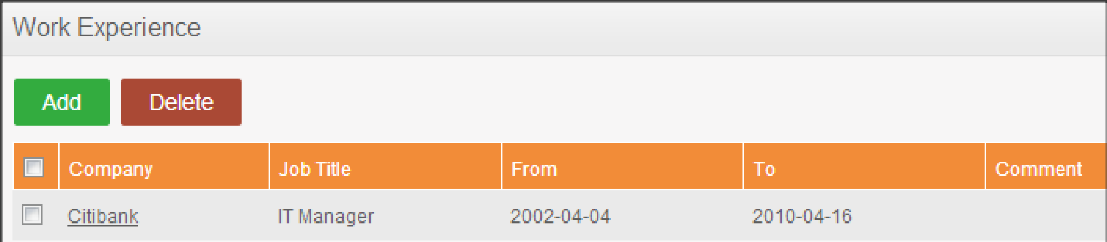

You may enter multiple entries of work experience.

Work experience can be edit. User will click on Company name and Edit Work Experience form will be opened. All fields keep same properties as into the create mode. After changes save button will be clicked User will be inform that modifications were saved.

To delete an entry, click on the check box next to a particular entry and then delete buton. It is also possible to delete multiple entries at the same time by clicking the check box entries you wish to delete and simply clicking “Delete”. User will be inform that entry was deleted.

**● Education**

You are able to enter details of your education here. To enter education details, click “Add” under “Education” and the screen as shown in Figure 1.4 will appear.

**Figure 1.4** 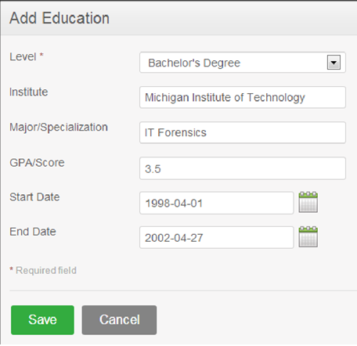

The form will contain:

* Level – mandatory field- drop down list containing :
  + High School Diploma
  + Bachelor’s Degree
  + Master’s Degree
* Institute – optional field – string – max 100 characters. When max is reached user cannot type
* Major/Specialization – optional field – string – max 100 characters. When max is reached user cannot type
* GPA/Score – optional field – string – max 100 characters. When max is reached user cannot type
* Start Date – optional field – date type – value cannot be in future
* End Date – optional field – date type

Click “Save” once all the fields are entered and the particular education details will be listed as shown in Figure 1.5

**Figure 1.5** 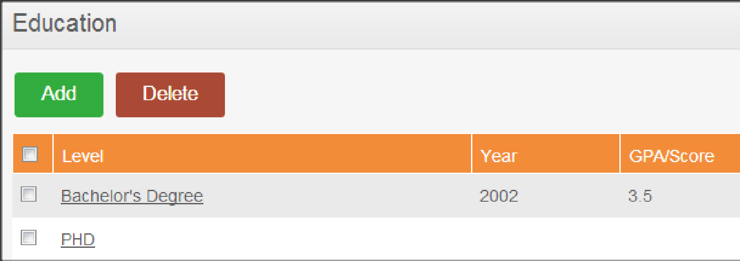

You may enter multiple entries of education.

Education can be edited. User will click on Level’s name and Edit Education form will be opened. All fields keep same properties except Level. Level field is not editable in edit mode. After changes save button will be clicked. User will be inform that modifications were saved.

To delete an entry, click on the check box next to particular entry and after press delete button. It is also possible to delete multiple entries at the same time by clicking the check box entries you wish to delete and simply clicking “Delete”. User will be inform that entry was deleted.

**● Skills**

If you have any special talents or skills they can be entered here. To enter skills, click “Add” under “Skills” and the screen as shown in Figure 1.6 will appear.

**Figure 1.6** 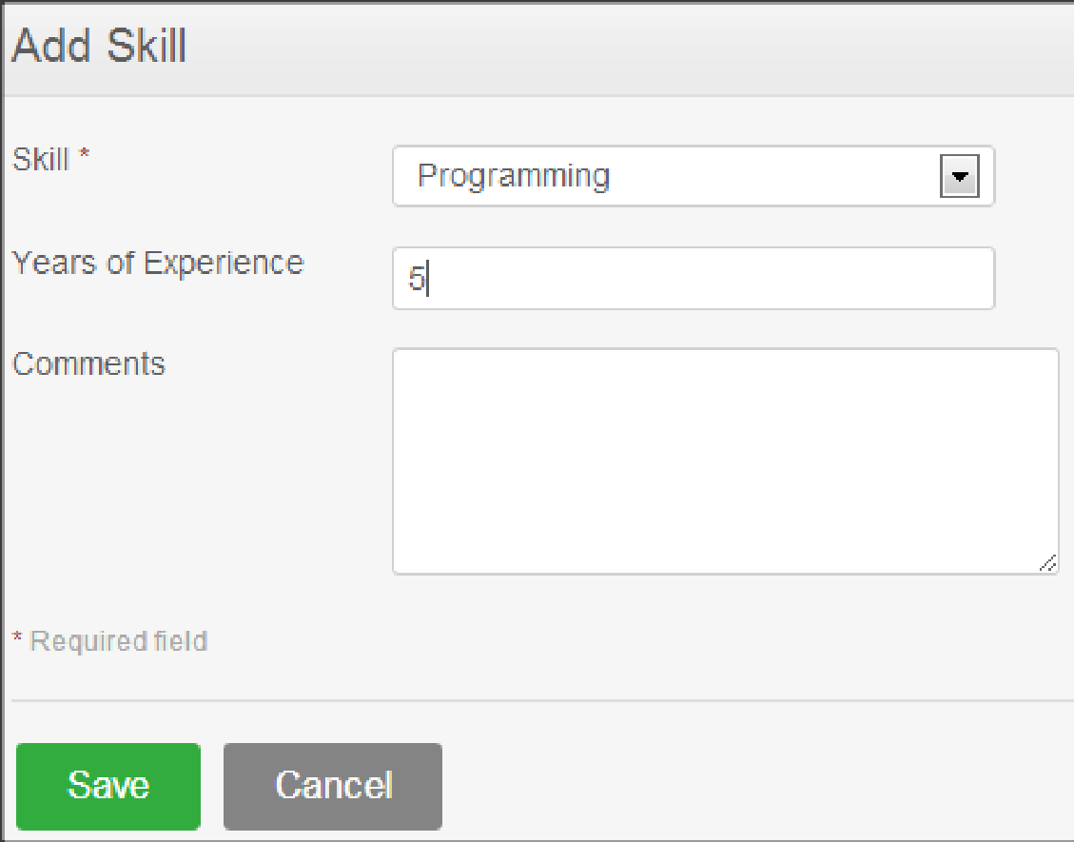

The form will contain:

* Skill – mandatory field – drop down with values :
  + C#
  + C/C++
  + Content Creation
  + Copywriting
  + G Suite
  + Google Analytics
  + Java
  + JavaScript
  + JIRA
  + Office Suite
  + Perl
  + Photoshop
  + PHP
  + Python
  + React Native
  + Ruby
  + SQL
  + Swift
  + Testing
  + Trello
  + UI/UX Design
  + Wireframing
* Years of Experience – optional field – string type , max 100 characters. When max is reached , user is not allowed to type
* Comments – optional field – will allow maximum 255 characters and will display a message for the user when max is reached

Click “Save” once all the fields are entered and the particular skill will be listed as shown in Figure 1.7

**Figure 1.7** 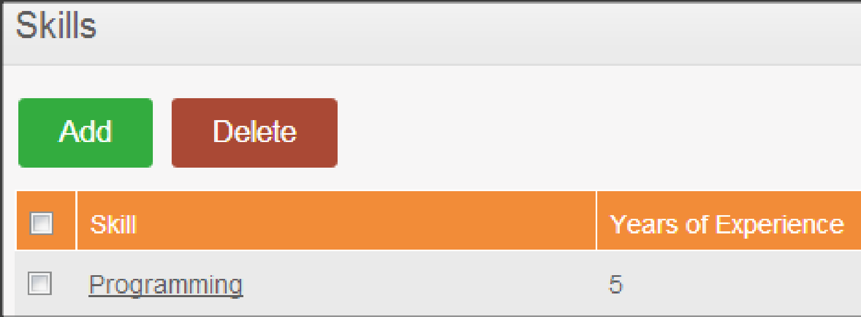

You may enter multiple entries of skills.

Skills can be edited. All Fields are editable and Skill remains a mandatory field.

To delete an entry, click on the check box next to particular entry and simply press delete button. It is also possible to delete multiple entries at the same time by clicking the check box entries you wish to delete and simply clicking “Delete”.

**● Languages**

You can enter the various languages that you are competent in, with the level of competency. To enter your language of competency, click “Add” under “Language” and the screen as shown in Figure 1.8 will appear.

**Figure 1.8** 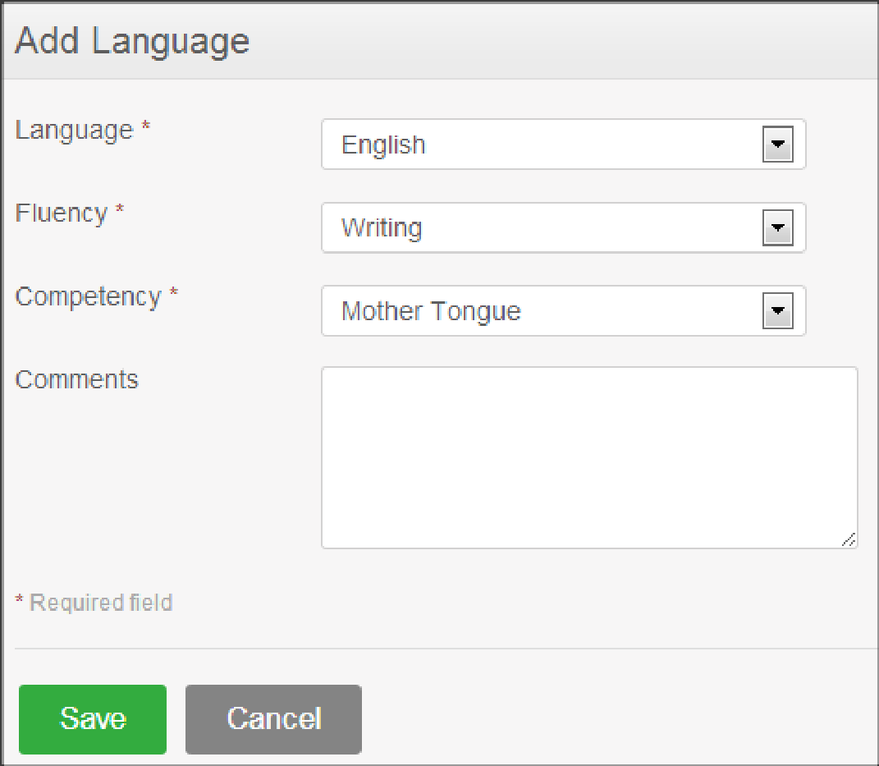

The form will contain:

* Language - mandatorey field – dropdown list type with values : Arabic, Chinese, English, French, Russian, Spanish
* Fluency – mandatory field – dropdown list with values: Poor, Basic, Good, Mother tanque
* Competency – mandaroty field – dropdown list with values: Reading, Speaking, Writing
* Comments – optional field – maximum permitted characters 100.

Click “Save” once all the fields are entered and the particular language of competency will be listed as shown in Figure 1.9

**Figure 1.9**  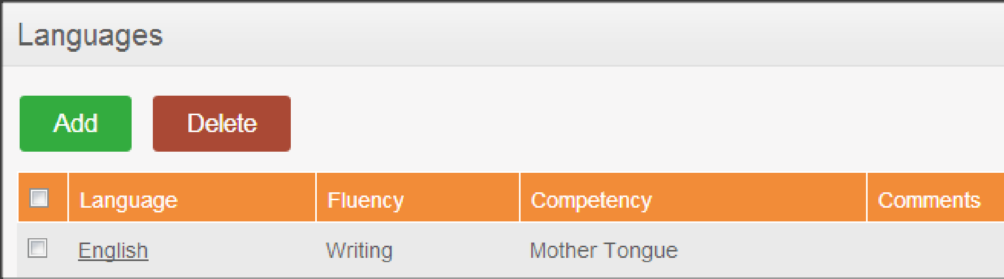

You may enter multiple entries of languages.

Languages are editable. Press on language and edit form will be opened. Language and Fluency are not editable.

To delete an entry, click on the check box next to particular entry and press delete button. It is also possible to delete multiple entries at the same time by clicking the check box entries you wish to delete and simply clicking “Delete”.

**● License**

Here you can enter the licenses that you may have. To enter licenses, click “Add” under “License” and the screen as shown in Figure 1.10 will appear.

**Figure 1.10** 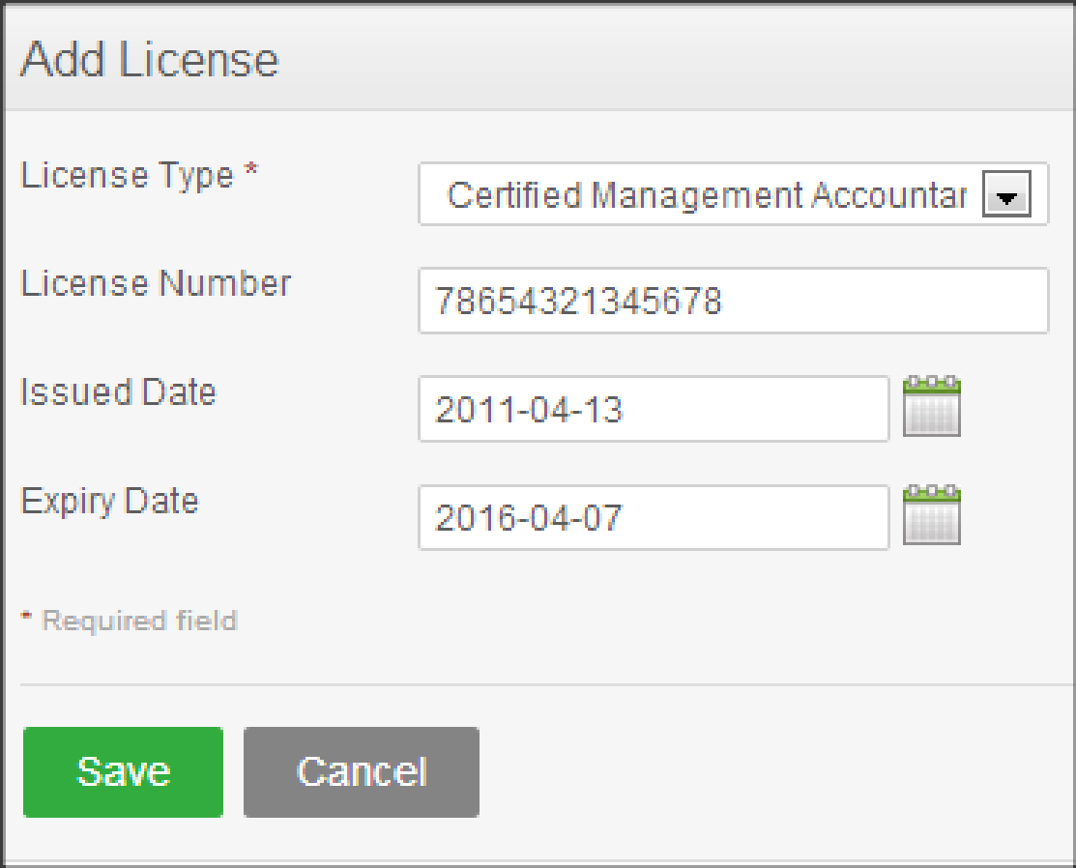

Add License form will contain:

* License type – mandatory field – dropdownlist type with values:
  + Certified Digital Marketing Professional (CDMP)
  + Certified Information Security Manager (CISM)
  + Cisco Certified Network Associate (CCNA)
  + Cisco Certified Network Professional (CCNP)
  + Microsoft Certified Systems Engineer (MCSE)
  + PMI Agile Certified Practitioner (PMI-ACP)
* License Number – mandatory field – string type – maximum 50 characters permitted. When max is reached user should not be allowed to type
* Issued Date – optional field – date type – value cannot be in future
* Expiry Date – optional field – date type

Click “Save” once all the fields are entered and the particular license will be listed as shown in Figure 1.11

**Figure 1.11** 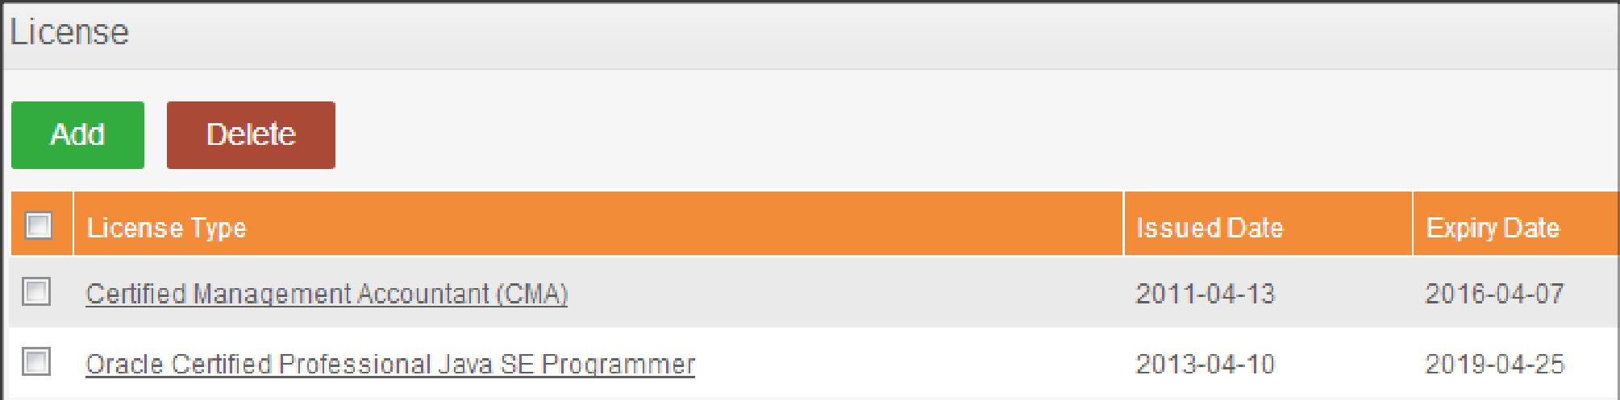

You may enter multiple entries of licenses.

Licenses are editable. Select License type in view and edit form will be opened. All fields are editable except License Type. Press save button to save changes.

To delete an entry, click on the check box next to particular entry. It is also possible to delete multiple entries at the same time by clicking the check box entries you wish to delete and simply clicking “Delete”.

**● Attachments**

Any supporting documents regarding your qualification that you think is needed by the management can be attached here. Please note that each document cannot exceed 1 megabyte, but you can attach more than one document. To add an attachment, click “Add” under attachment and the screen as shown in Figure 1.12 will appear.

Click “Browse” and select the file from the relevant path and click “Upload” to upload it. Comment field should permit maximum 200 characters and display a message if lenght is exceded. All files are permitted.

**Figure 1.12** 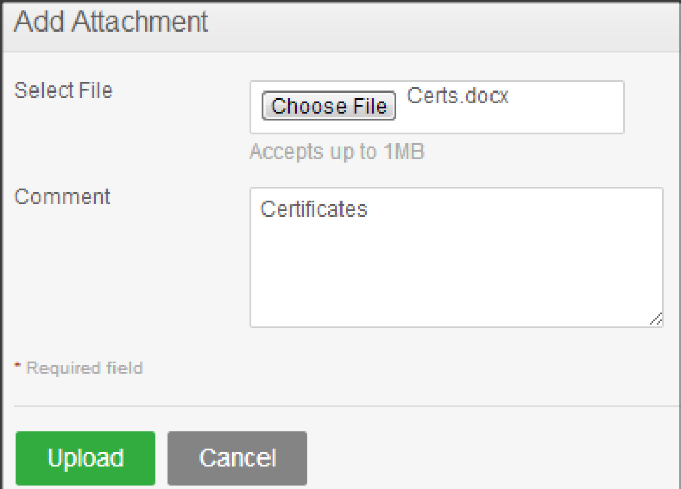

Once you have uploaded the file, the file will be listed as shown in Figure 1.13

**Figure 1.13** 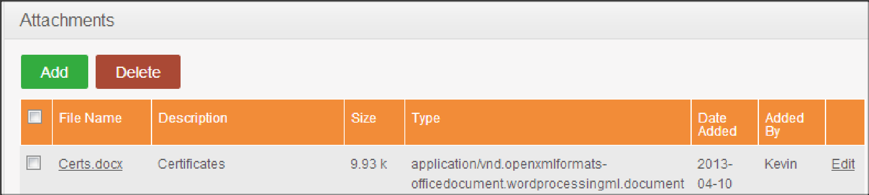

You may upload multiple attachments.

You can save/download document by select the file name.

Attachments can be edited using Edit option. In edit mode will be visible:

* The current File – non editable field
* Replace With – choose file field type
* Comment – optional field- string type , max 200 characters permited

In edit mode 3 buttons are available:

* Upload
* Save comment Only
* Cancel

To delete an entry click on the check box next to the particular entry and click “Delete”. Multiple selections can be deleted simultaneously.

# Sign-Off Document

_____________________________________________________________________________

The following parties have read and agree with this Requirements Definition document for the OrangeHRM application account module functionality.

After approval of this Requirements Definition phase, any significant changes in the scope of this project will require validation of existing project costs and schedules.

______________________________________ _________________________________

Name Date

Business Lead

______________________________________ ________________________________

Name Date

Project Manager